Sprint 4, D0018E Group 34

# Executive Summary:

DreamTeam Luleå is an e-commerce webstore made in Bootstrap Framework, PHP/JavaScript and SQL, that sells electronic devices / computer equipment. While it is primarily server-side programmed, it takes advantage of some client-side JavaScript to modify data before sending it to the database.

# User Roles:

* Admin (Role for employees that unlocks more permissions)
* Customer

# Scenarios/Use-cases:

* Admin adds a new product
* Admin edits/deletes a product
* Admin views current orders made by customers
* Admin changes user role of a user / deletes a user
* Customer logs in on site
* Customer adds products into his/her shopping cart and then checks out
* Customer deletes/clears his/her shopping cart
* Customer views/cancels his/her order(s)
* Customer edits his/her user settings
* Customer make an order
* Customer makes a review of a product
* Customer views other reviews posted by users
* An unregistered user makes an account

# Architecture:

* Bootstrap framework for HTML,
* PHP for the Back-end Server interaction,
* JavaScript for the Front-end client interaction,
* MySQL for the database.

We will use PHP to connect the SQL Database with the HTML website, and then use that connection to export and import data to and from the server. We are using JavaScript for client-side interactions. The bootstrap framework is just to make a neat looking website while simplifying the coding process.

GitHub link to code repository: <https://github.com/Mawn/D0018E-Databaser>

# Test-case Specifications (for sprint 4 only):

* Register a new account and log in
* Add three products to the cart, and then delete one manually and press ‘Clear Cart’ to empty it
* Add a new Product and then Remove it (Administrator)
* Change user settings for the logged in account
* Change user role / delete an account (Administrator)
* Change the amounts on products in cart to show an update in total price and amounts in database
* Check out and create an order and verify the order
* Change the Delivery Status of an Order (Administrator)
* Delete an Order (Administrator)
* Verify stock counts after making an order
* Review a product
* View various reviews made by users

# E-R Diagram:

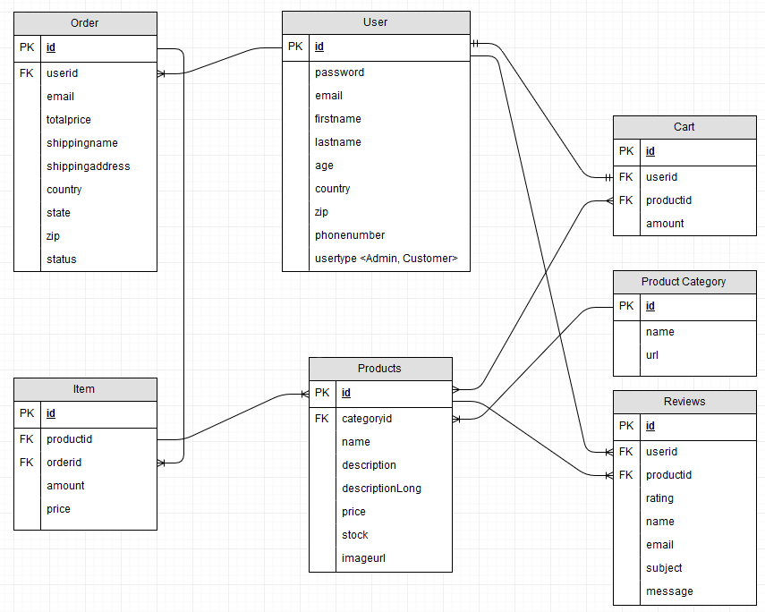

# Limitations and Improvements:

Currently you can create a new category in MySQL and a new category will appear in the html code, and while it links to the custom URL given in the “productscategory” table, you need to manually create new HTML/PHP files for it to work.

Improvements from Sprint 3 has mainly been design related and focused on providing a simple user experience while still having the same back-end experience.

# Backlog:

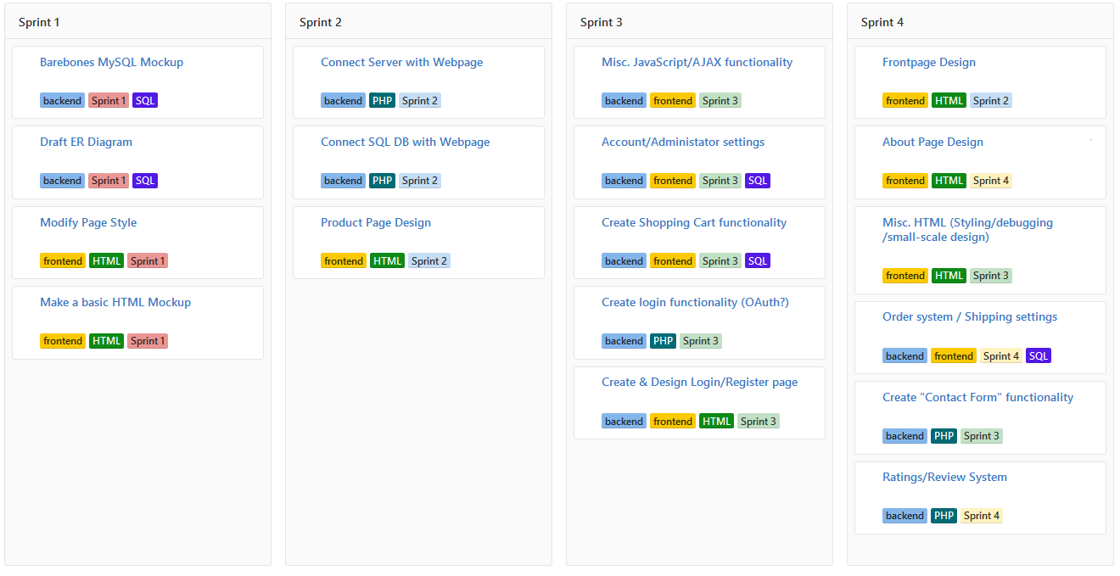

# Review System:

Because we didn’t have a review system in place when we presented our work, this section is to show how that system works.

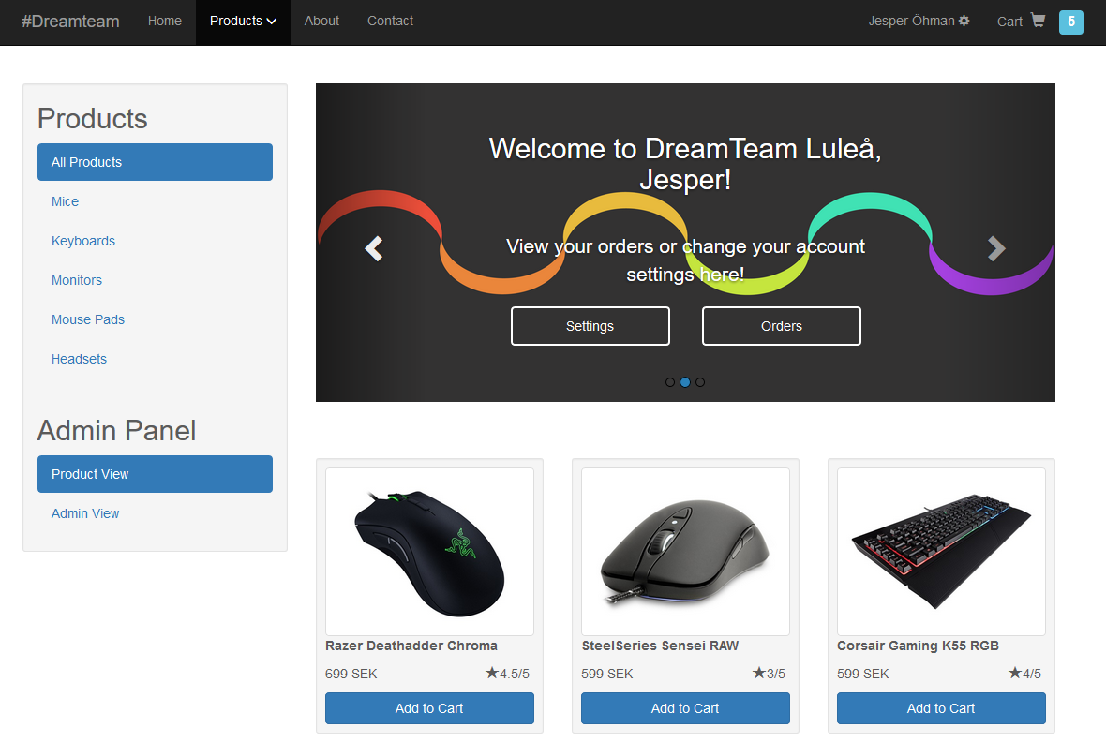

A product’s rating is the mean value of all rating values from user reviews. It’s shown on each product as shown in the picture above.

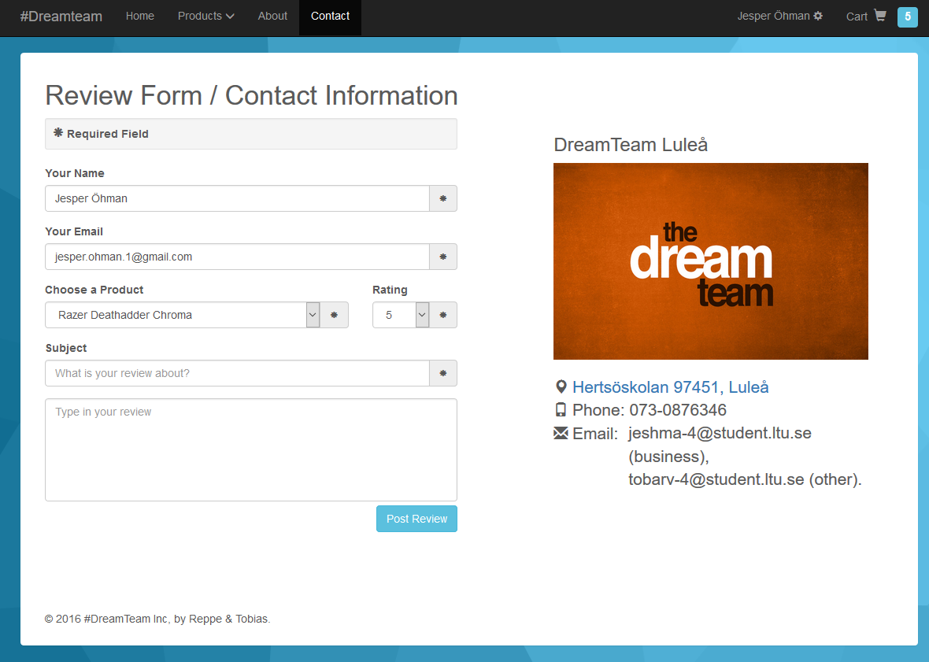

In order to review a product, a user has to fill in the required fields and then choose a product and a rating from drop-down menus.

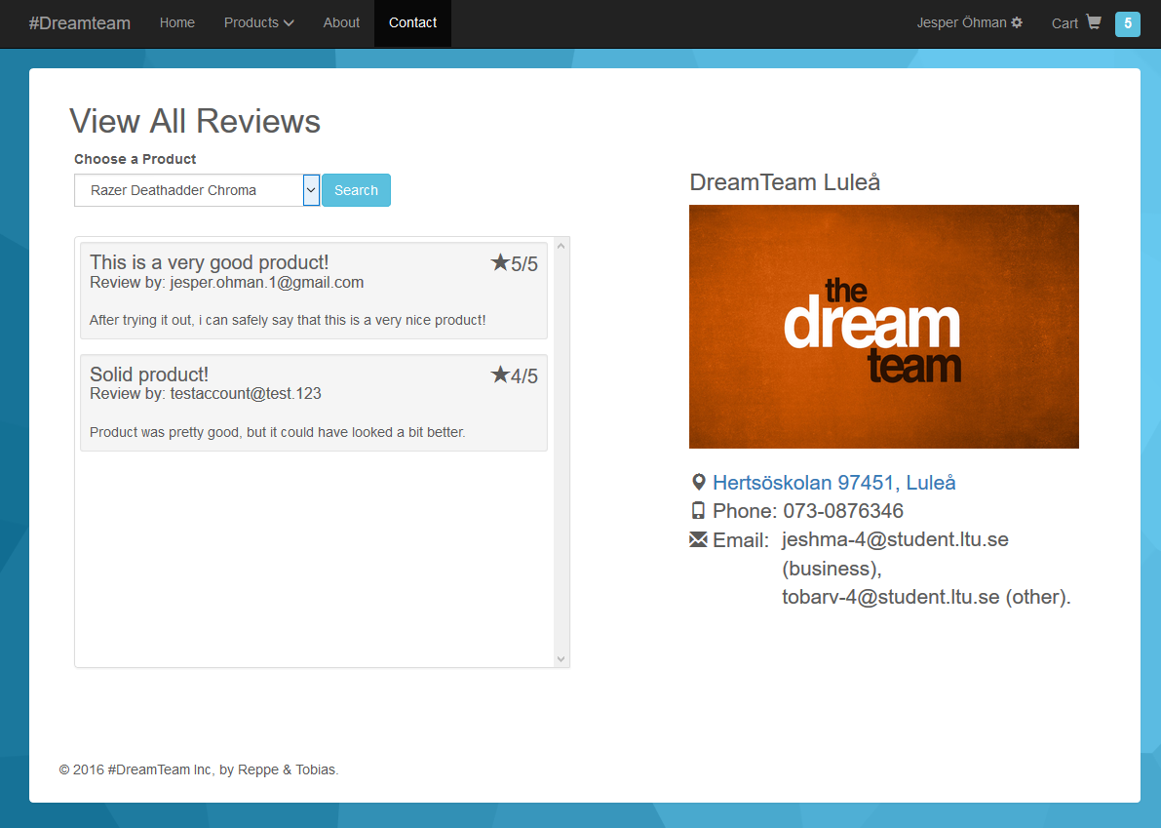

As shown above, this is the view of the user when they are looking at any review placed on a product, simply choose a product from the drop-down menu and click search to see all reviews for that product.

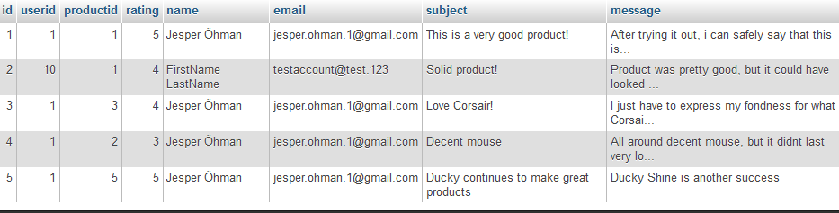

This is how the “Reviews” table looks like inside the database.